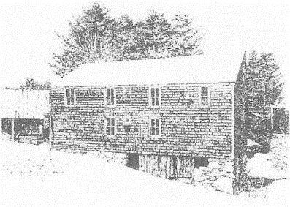
Sanborn Mills Farm
2018 Oxen Workshop Questionnaire

The skills taught in our 2018 oxen workshops are designed for individuals who want to build up their skills as a teamster. We ask everyone taking an oxen workshop to fill out this questionnaire so we can customize the training to your particular needs. Please return at least three weeks before the start date of your workshop to Tim Huppe, Farm Manager.
Email: tim@sanbornmills.org
Regular mail: Tim Huppe, Farm Manager
Sanborn Mills Farm
7097 Sanborn Road
Loudon, NH 03307

Please type or print clearly -Use additional paper if needed
Name:
Mailing Address:
Email Address:
Home Phone: Cell Phone:
Age:
Occupation (optional):
Workshop/s & dates you signed up for:

- Do you have any previous experience with training and/or working with cattle?
YES____ NO_____
If yes, please explain.

- Have you owned or currently own any type of cattle (steers, oxen, heifers, or cows)?
YES____ NO_____
If yes, what did or do you have?

What type of work did you or are you doing with them?

- What are your personal goals in taking this workshop?

