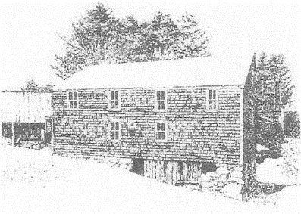

Sanborn Mills Farm
2016 Oxen Workshop Questionnaire

The skills taught in our 2016 oxen workshops are designed as a series and intended for individuals who want to build up their skills as a teamster. Because want to make sure that you individuals are ready for what we have to offer, participation in the workshops listed below (#2, #3, & #4) is contingent upon filling out this questionnaire and participating in a telephone conversation with Sanborn Mills Farm Manager and head oxen instructor Tim Huppe.

- #2-Logging with Oxen – May 25 - 27, 2016 – Learn how travel woods roads and harvest wood safely and efficiently using a scoot, chains, peavey, a brow and other logging equipment.

- #3-Working Cattle on the Farm and in the Garden – July 20 - 22, 2016 – Learn how to plow and cultivate effectively in a home or market garden and perform other basic farm skills using a variety of farm equipment including wagons and scoots.

- #4- Ox Yoke Making – September 13 - 16, 2016 – Learn how to make comfortable ox yokes that will allow your team to do their best as they grow in size.

If you are interested in taking one of these workshops, fill out the Oxen Workshop Questionnaire and email or send it at least three weeks before the start date of the workshop. Send it to:
Mary Witschonke, Administrative Assistant
mary@sanbornmills.org
Sanborn Mills Farm
7054 Sanborn Road, Loudon, NH 03307

You will be contacted by Farm Manager and lead oxen instructor Tim Huppe within one week of our receiving your completed questionnaire to set up a time for a phone meeting to discuss your interests and background.

Note: Minimum age of participants will vary by workshop.
Sanborn Mills Farm
2016 Oxen Workshop Questionnaire
Please type or print clearly
Use additional paper if needed

Name:
Mailing Address:
Email Address:
Home Phone: Cell Phone:
Age:
Occupation (optional):

- What workshop/s are you interested in taking?

- Do you have any previous experience with training and/or working with cattle?
YES____ NO_____
If yes, please explain.

- Have you owned or currently own any type of draft cattle (steers, oxen, heifers, or cows)?
YES____ NO_____
If yes, what did or do you have?

What type of work did you or are you doing with them?

- What are your personal goals in taking this workshop?

Signature Date

