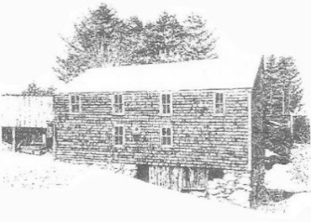
Sanborn Mills Farm
2017 Workshop Registration Form

Please use this form to register for a workshop if you are making a deposit or if you are unable to register on our website www.sanbornmills.org using PayPal.

A one-day deposit is due upon registration to hold your space. The balance is due on the first day of the workshop. The one-day deposit rates for the 2017 workshops are:
- Blacksmithing - $125
- Oxen – all 2–day workshops - $150 – Ox Yoke Making - $100
- Traditional Painted Floor Cloth - $125
- Basket Making - $80

Please make your check payable to: Sanborn Mills, Inc.

Mail this form with your check to: Lynn Martin Graton
Programs & Research
Sanborn Mills Farm
7097 Sanborn Rd
Loudon, NH 03307

Note: Workshop cancellations made at least 2 weeks before a workshop start date will receive a refund minus a non-refundable $25 registration fee.

First & Last Name: | Date:
Street Address:  City:  State & Zip: | Daytime Phone #:  Evening Phone #:
Email Address:

Workshop you are registering for:

Date(s):
Full Cost of Workshop: | Amount Enclosed:

Questions? Call 603-435-7314 and ask for Lynn Martin Graton

