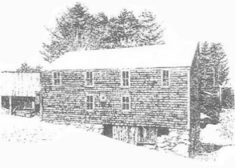
Sanborn Mills Farm
2019 Workshop Registration Form

Thank you for your interest in workshops at Sanborn Mills Farm. Please use this form to purchase a workshop if paying with a check. A 50% deposit is due with this form. The balance is due 30 days prior to the workshop start date.

Please make check payable to: Sanborn Mills, Inc.
Mail this form with your check to: Programs & Research
Sanborn Mills Farm, 7097 Sanborn Rd, Loudon, NH 03307

Who are you registering?
Name: Date:

Address:

Date of Birth:

Daytime Phone:
Email:

Purchaser Information □ - Check this box same as person being registered:

Name:

Address:

Date of Birth:

Daytime Phone:
Email:

Workshop Title & Date:

Full Cost of Workshop: | Amount Enclosed:

CANCELLATION & CHANGE POLICY: Cancellations must be made at least 30 days prior to the start date of a workshop in order to receive a refund. Refunds are the amount paid for the workshop minus a non-refundable $25 registration fee. Refunds for gift certificates are to the purchaser only. Request to change to a different workshop date must also be made 30 days prior to a workshop start date. Each workshop must have a minimum number of students to be held. If Sanborn Mills Farm finds it necessary to cancel a workshop, we will notify those students who have registered at least two weeks prior to the start date of a workshop and a FULL refund will be provided. If you have questions, please contact the office at 603-435-7314 weekdays from 9am to 3 pm. (as of 8/02/18)

