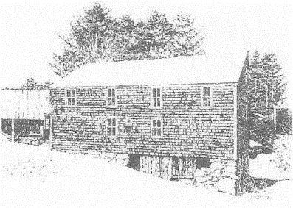
Sanborn Mills Farm
2019 Oxen Workshop Questionnaire

The skills taught in our 2019 oxen workshops are designed for individuals who want to build up their skills as a teamster. We ask students who have never taken an oxen workshop to fill out this questionnaire so we can customize the training to your particular needs. Please return it at least two weeks before the start date of your workshop to Tim Huppe.
Email: tim@sanbornmills.org
Regular mail: Tim Huppe
Sanborn Mills Farm
7097 Sanborn Road
Loudon, NH 03307

Please print clearly and feel free to use additional paper if needed.
Name:
Mailing Address:
Email Address:
Home Phone: Cell Phone:
Age:
Occupation (optional):
Workshop/s & dates you signed up for:

- Do you have any previous experience with training and/or working with cattle?
YES____ NO_____
If yes, please explain.

- Have you owned or currently own any type of cattle (steers, oxen, heifers, or cows)?
YES____ NO_____
If yes, what did or do you have?

What type of work did you or are you doing with them?

- What are your personal goals in taking this workshop?

