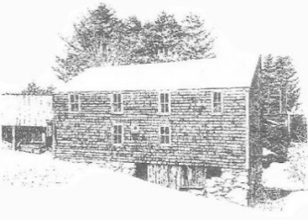
Sanborn Mills Farm
2018 Workshop Registration Form

Please use this form to register for a workshop if you are making a deposit to reserve a space or if you are unable to register on our website www.sanbornmills.org.

A minimum of a one-day deposit is due upon registration to hold your space. The balance is due on the first day of the workshop. The one-day deposit rates for the 2018 workshops are:
- Blacksmithing - $125
- Oxen Skills - $150
- Ox Yoke Making - $100
- Traditional Painted Floor Cloths - $125
- Basket Making - $100

Please make your check payable to: Sanborn Mills, Inc.
If paying by credit card, please call the office at 603-435-7314 weekdays from 9 am to 3 pm.

Mail this form with your check to: Sanborn Mills Farm
Programs & Communications
7097 Sanborn Rd
Loudon, NH 03307

First & Last Name: | Date:
Street Address:  City:  State & Zip: | Daytime Phone #:  Evening Phone #:
Email Address:

Workshop title & dates you are registering for:

Full Cost of Workshop: | Amount Enclosed:
Will you need housing at the farm? □ Yes □ No
If so, what nights would you like to reserve?
(The cost is $60 single room and$90 for a double room and you can pay when you arrive at the farm.)

NOTE: Owing to the amount of time and effort that goes into planning a workshop, if you need to cancel your registration, you must do so 30 days before the start date of the workshop in order to receive a refund. There is a non-refundable registration fee of $25. If a minimum number of students has not registered, a workshop may be cancelled. Cancellations are typically made at least two weeks prior to the start date of a workshop and a full refund will be provided.

